AI Based Conversational IVR Modernization Framework
Abstract:
Traditional Interactive Voice Response (IVR) systems used in large public service environments typically operate through fixed menu options that rely on Dual Tone Multi Frequency (DTMF) keypad inputs. These conventional systems often lead to longer interaction times, reduced flexibility, and a less satisfactory user experience, especially for users who are unfamiliar with complex menu navigation. To address these limitations, this project introduces a Conversational IVR Modernization Framework that enhances existing IVR systems by incorporating Conversational Artificial Intelligence. This enables users to interact with the system using natural voice commands instead of relying solely on keypad inputs.

Using the IRCTC system as a reference model, the proposed solution demonstrates how legacy VoiceXML-based IVR systems can be upgraded without fully replacing the current infrastructure. The approach involves implementing a middleware integration layer that connects the traditional IVR system with modern AI-based conversational services. This middleware captures voice input from users, converts speech into text using AI-powered speech recognition, processes the request, retrieves relevant information from simulated datasets, and delivers responses through voice synthesis.

This enhanced system improves overall usability by simplifying navigation and reducing response time. Additionally, the framework is highly adaptable and can be applied across various sectors such as banking, telecommunications, and government support services, making it a scalable and efficient solution for modernizing IVR systems.

Introduction:
Many organizations rely on Interactive Voice Response (IVR) systems to manage customer interactions automatically. These systems enable users to obtain information by calling a service number and selecting options through keypad inputs, eliminating the need to speak directly with a human representative. IVR solutions are widely implemented in sectors such as transportation, banking, telecommunications, and various public service departments.
Conventional IVR systems typically operate using structured and predefined menu flows. Users are required to listen carefully to recorded instructions and respond by pressing specific keys, such as selecting options for PNR status or train schedules. Although functional, this approach can often be slow and complicated. Callers may need to navigate through multiple layers of menus before reaching the desired service, which increases the overall call duration.
In large-scale public platforms like IRCTC, a significant number of users depend on IVR systems for railway-related information. Due to lengthy menu structures, unclear prompts, language barriers, and repetitive input requirements, users frequently experience frustration. As a result, call handling time increases, and some users may disconnect before receiving the required information.
Advancements in Artificial Intelligence and speech recognition technologies now provide opportunities to enhance traditional IVR systems. Modern conversational IVR solutions allow users to communicate naturally by speaking their queries, such as requesting PNR details. The system processes the spoken input, identifies the user’s intent, and delivers accurate responses without relying on keypad-based navigation.
The objective of this project is not to completely replace the existing IRCTC IVR infrastructure but to enhance it by introducing an AI-powered conversational layer. This is achieved through a middleware integration approach that connects the legacy IVR system with advanced AI services. By doing so, intelligent voice interaction is enabled while preserving the original system architecture.
Using IRCTC as a reference case, this project demonstrates how traditional IVR frameworks can be transformed into conversational systems. The proposed solution enhances user experience, minimizes call complexity, and provides a scalable and adaptable framework for future IVR modernization across multiple domains.

Problem Statement:
The objective of this project is to upgrade existing IVR (Interactive Voice Response) systems that are developed using VoiceXML (VXML) by integrating them with advanced Conversational AI platforms such as ACS and BAP services. Instead of completely replacing the current infrastructure, the proposed solution focuses on utilizing and extending the existing legacy components. By introducing a conversational layer, the system will enable natural voice-based interactions while preserving the core IVR framework.
The modernization approach aims to enhance system usability, improve overall user experience, and simplify navigation processes. Additionally, it seeks to reduce the complexity and technical challenges involved in migrating traditional IVR systems to AI-enabled conversational workflows, ensuring a smoother and more cost-effective transition.

Objective :
• To analyze the existing IVR systems currently used across various platforms, including IRCTC, in order to understand their structure and limitations.
• To design and develop a conversational IVR framework that allows users to interact with the system using natural voice commands instead of relying on keypad-based navigation.
• To implement a middleware-based integration layer that connects legacy IVR systems with modern conversational AI technologies without modifying the original infrastructure.
• To capture user voice input and convert it into text using speech recognition technologies, and to determine the user’s intent using Artificial Intelligence.
• To retrieve relevant information from the database or simulated data sources based on the user’s request.
• To generate and deliver voice responses to users in a clear, simple, and understandable format using text-to-speech technology.
• To enhance the overall user experience by reducing navigation complexity, minimizing response time, and improving system efficiency.
• To demonstrate a scalable and reusable IVR modernization model that can be extended and applied to other domains such as banking, telecommunications, and government service systems.

Traditional System – Legacy IVR :
The existing IVR systems used across many platforms operate using a traditional menu-driven approach. These systems follow a predefined sequence of instructions that users must navigate by responding through their phone keypad. The interaction process is fixed, and users are required to follow the structured menu flow to access the desired service.
Working of the Traditional IVR System
User Initiates a Call
• The user dials the customer service or enquiry number provided by the organization.
Playback of Pre-recorded Messages
• Once the call is connected, the system plays automated voice prompts that guide the user.
• These prompts typically include instructions such as:
• “Press 1 for PNR status”
• “Press 2 for train timings”
User Provides Input through Keypad (DTMF Input)
• The user responds by pressing specific keys on their phone keypad according to the given options.
• These keypad inputs generate signals known as Dual Tone Multi Frequency (DTMF), which are recognized by the IVR system to determine the user’s selection.
VoiceXML-Based Call Flow Management
• The entire interaction process is controlled using VoiceXML, which defines the call flow and system behavior.
• VoiceXML determines which message should be played, how the system should respond to user input, and what actions should be performed next.
Fixed and Rigid Menu Structure
• The traditional IVR system follows a strict and sequential menu structure.
• Users must navigate through each step in order, without the flexibility to skip options or interact naturally using voice commands.
• This limited interaction model often makes the system less efficient and less user-friendly.

Legacy IVR Architecture :
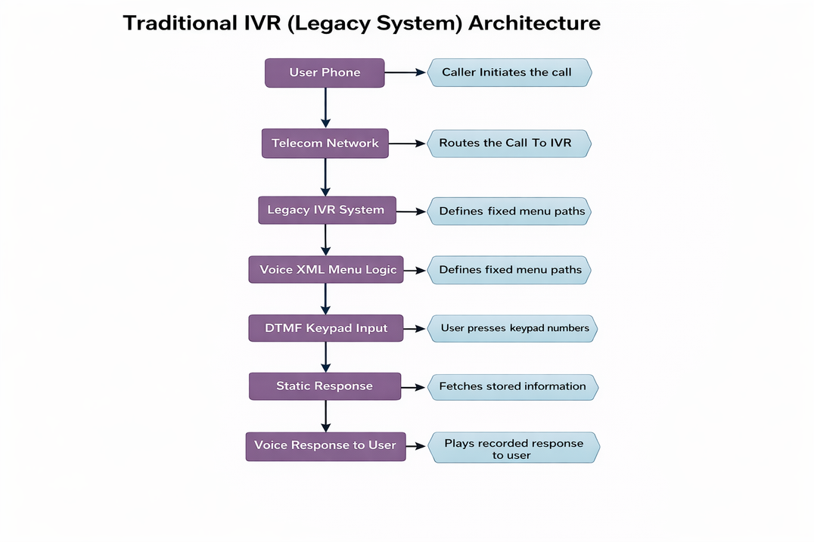

Proposed System – Modern Conversational IVR :

The proposed system introduces a Modern Conversational IVR framework that enables users to interact with the system using natural voice commands rather than relying on keypad-based inputs. This approach enhances the overall user experience while preserving the existing legacy IVR infrastructure. Instead of navigating through predefined menu options such as “Press 1” or “Press 2,” users can directly state their request in natural language.
The system captures the user’s spoken input, processes it using Artificial Intelligence, identifies the user’s intent, retrieves the relevant information, and provides an appropriate voice response. This conversational approach simplifies interaction and makes the system more accessible and user-friendly.
Rather than replacing the traditional IVR system, the proposed solution introduces a middleware integration layer that connects the legacy IVR with modern conversational AI technologies. This integration enables intelligent voice interaction while maintaining compatibility with the existing system architecture.
Working of the Proposed System :
User Initiates the Call
• The user dials the IVR service number to access the system.
Voice Input Capture
• Instead of pressing keypad buttons, the user communicates using natural speech.
• For example, the user may say, “Check my PNR status.”
Speech-to-Text Conversion
• The spoken input is processed using speech recognition technology, which converts the audio into text format.
Intent Recognition using AI
• The converted text is analyzed using conversational AI to determine the user’s intent and identify the requested service.
Data Retrieval
• Based on the identified intent, the system retrieves relevant information from the database or simulated IRCTC data source.
Text-to-Speech Conversion and Response Delivery
• The system converts the generated text response into speech using text-to-speech technology.
• The voice response is then delivered back to the user, completing the interaction.

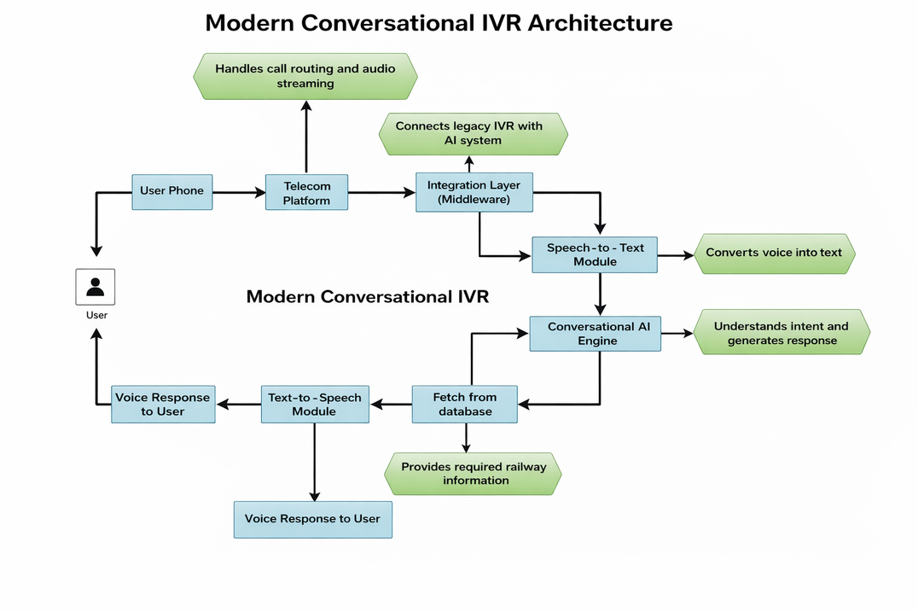
Technology Stack:

Component | Technology Used
Communication Layer | Twilio / Azure Communication Services (ACS) / BAP
Backend Development | Python with Flask framework
Artificial Intelligence | OpenAI API for conversational intelligence
Speech Recognition | Whisper speech-to-text engine
Data Management | JSON files and database systems
Application Platform | IRCTC (used as reference case study)

Twilio-Based Conversational IVR Workflow Overview :
The Twilio communication platform acts as a bridge between the caller and the conversational AI system. It manages incoming calls, forwards audio to the backend server, and delivers the generated response back to the user.
Working Flow:
- Call Initiation
The user places a call to the IVR number provided by the service.
- Call Handling by Twilio
Twilio receives the call and forwards the audio stream to the backend application server.
- Backend Processing
The backend application developed using Python and Flask receives the audio input and prepares it for AI processing.
- AI-Based Understanding
The conversational AI system analyzes the request, identifies user intent, and determines the appropriate response.
- Response Generation
The backend retrieves required information from the database or simulated IRCTC data and prepares a response.
- Response Delivery via Twilio
Twilio converts the response into voice format and plays it back to the caller.
- User Receives Voice Output
The user hears the generated response, completing the conversational interaction

Caller
│
Twilio Communication Platform
│
Backend Server (Python + Flask)
│
Conversational AI Engine (OpenAI API)
│
Database / IRCTC Data
│
Response Generation
│
Twilio Voice Output
│
User Receives Respons

Technical Challenges :
1. Speech Recognition Reliability
Accurately converting spoken language into text can be difficult, especially when users have different accents, speak quickly, or there is background noise. These factors may lead to incorrect interpretation of user requests.
2. Response Time Delays
Since the system relies on multiple components such as speech processing, AI analysis, and external API communication, slight delays may occur before the final response is delivered to the user.
3. Dependence on External Platforms
The solution depends on third-party services such as Twilio, OpenAI APIs, and speech processing tools. Any service interruption, downtime, or API limitation from these providers can impact the overall system performance.
4. Concurrent Call Management
Handling multiple callers at the same time requires efficient system design and resource management. Ensuring smooth performance without delays or failures during high traffic is a significant technical challenge.
5. Data Security and Privacy Protection
User information and voice data must be handled securely. Proper encryption, secure storage, and controlled access mechanisms are necessary to prevent unauthorized access and ensure user privacy.
Constraints :
1. Internet Connectivity Requirement
The system depends on a stable and reliable internet connection for communication between telecom services, backend servers, and AI components. Any interruption in connectivity may affect system performance.
2. Reliance on External APIs
This framework uses third-party services such as Twilio and AI-based APIs for handling calls, speech processing, and response generation. The availability and performance of these services directly impact system functionality.
3. Use of Simulated Data
The project operates using simulated IRCTC data instead of connecting to live railway databases. This limitation exists because real-time integration requires official access and security authorization.
4. Limited Deployment Scope
This system is designed primarily as a prototype or demonstration model for academic and learning purposes. It is not currently deployed in real-world railway or telecom production environments.
5. Operational Cost Considerations
Continuous usage of cloud services, APIs, and telecom platforms may involve usage-based costs. These expenses must be considered when scaling the system for large-scale deployment.
Integration Challenges :
1. Integration Limitations with Legacy VoiceXML Systems
Traditional IVR systems built using VoiceXML were not designed to support conversational AI. Additional middleware is required to enable communication between legacy systems and modern AI services.
2. Communication Protocol Differences
Legacy IVR platforms and modern AI systems may use different communication standards and protocols, making integration more complex and requiring proper adaptation layers.
3. Variations in Speech Recognition Models
Speech recognition accuracy may differ depending on language, accent, pronunciation, and environment, which can affect system reliability in diverse real-world scenarios.
4. Telecom Infrastructure Limitations
Existing telecom hardware and infrastructure may not fully support advanced conversational features, which can limit the implementation of modern voice interaction capabilities.
5. Scalability Challenges in Legacy Systems
Older IVR systems were not designed to handle high-volume AI processing. Scaling conversational AI features for large numbers of concurrent users requires additional system optimization and cloud support.
Conclusion :
This project focuses on modernizing traditional IVR systems by integrating them with advanced conversational AI technologies. Instead of relying solely on keypad-based menu navigation, the proposed solution enables users to interact naturally through voice commands. This significantly improves usability and enhances the overall customer experience.
A middleware integration layer plays a crucial role in connecting the legacy VoiceXML-based IVR system with modern AI services. This approach ensures that the existing infrastructure remains intact while enabling intelligent conversational capabilities. By avoiding complete system replacement, the solution reduces redevelopment effort and cost.
The project currently operates using simulated data for demonstration purposes; however, the architecture is designed in a scalable manner. In the future, the same model can be extended to integrate with real-time enterprise systems such as railway, banking, healthcare, or customer support platforms.
Overall, the proposed system demonstrates how legacy IVR platforms can be efficiently transformed into intelligent, AI-driven conversational systems while maintaining compatibility with existing telecom infrastructure.

